Sketch

# Description

Sketch, which belong the low-fidelity prototype group, is a paper-based prototype usually created by hand. It is used to sketch interaction designs and interfaces. It allows to easy suggest, explore, trigger questions, propose, make attempts without fearing, as it is not definitive.

# Benefits

* easier to talk on something that is visual and concrete instead to more abstract concept
* give a first look and feel of the interface
* help the designer to drawn down her/his own ideas
* means of communication within designer, between designers and users and between designers and stakeholder: it helps discussion regarding what users and stakeholder want and need from the future system
* represent and help to explore design ideas, screen layouts and design alternatives in order to make decisions and develop the best design
* represent not detailed interface, just enough to have an idea on how it would work
* Potential usability problems can be detected at a very early stage in the design process before any code has been written.
* Paper prototypes are cheap and quick to build / refine, thus enabling rapid design iterations.
* Only minimal resources and materials are required.
* Heaton [4][1] believes that rapid prototyping should solve 80% of the major interface problems
* It gives the opportunity to the users to have ideas of what is possible to do

disadvantage:

* detecting erros is limited
* not detailed enough for development
* simulation of navigation and flow is limited

# Best practices

* use them a lot and mostly in the early stage of the development
* don’t stuck on details
* focus on representing the most common tasks, leave the less important for later

# Examples

### Planning

Arrange a workshop attended by:

* user(s)
* developer(s)

You will also need a facilitator and a person to record the issues raised during the meeting.

Four stages of paper prototyping may be required:

* concept design: to explore different metaphors and design strategies
* interaction design: to organise the structure of screens or pages
* screen design: for initial design of each individual screen
* screen testing: to refine the screen layout

### 1. Concept design

* Sit round a table and sketch out possible approaches in a brainstorming environment.
* Evaluate the extent to which each approach meets the usability requirements and objectives agreed in the [stakeholder meeting](http://www.usabilitynet.org/tools/stakeholder.htm)

### 2. Interaction design

* Write the name of each suggested screen, page or activity on a post-it-note.
* Put each post-it-note on the wall close to related notes.
* Group the post-it-notes in clusters that are meaningful to users.
* Consolidate duplicates.
* Give a name to each cluster.
* Document the sequence in which user tasks will make use of each set of post-it-notes
* Review how the screens/pages can be organised to simplify user tasks,

### 3. Screen design

* Sit round a table and sketch out design ideas in a [brainstorming](http://www.usabilitynet.org/tools/brainstorming.htm) environment.
* Use this as a basis for rough sketches of each screen.
* If the links between screens have not been finalised, pin each screen on the wall as for Interaction Design above,
* Ask the user to carry out a realistic task (based on the [context of use](http://www.usabilitynet.org/tools/context.htm) and [scenarios](http://www.usabilitynet.org/tools/scenarios.htm))
* As the user selects options on each screen, the developer explains what happens, and either points to the next screen or presents the next screen to the user (without giving any hints).

### 4. Screen testing

* Use a drawing package or prototyping tool to produce a rough design for each screen.
* If the links between screens have not been finalised, pin each screen on the wall as for Interaction Design above.
* Ask the user to carry out a realistic task (based on the [context of use](http://www.usabilitynet.org/tools/context.htm) and [scenarios](http://www.usabilitynet.org/tools/scenarios.htm)).
* As the user selects options on each screen, the developer explains what happens, and either points to the next screen or presents the next screen to the user (without giving any hints).
* To test more detailed interaction, prepare pieces of paper with menus, scroll boxes, dialogue boxes, etc., and present these to the user. The user simulates pointing and clicking using a pencil, and simulates typing by writing on paper.

<http://www.usabilitynet.org/tools/prototyping.htm>

<http://www.usability.gov/how-to-and-tools/methods/prototyping.html>

libro. P. 115-117

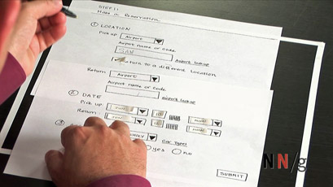

<http://www.nngroup.com/reports/paper-prototyping-training-video/>

<http://www.interaction-design.org/encyclopedia/activity_theory.html>

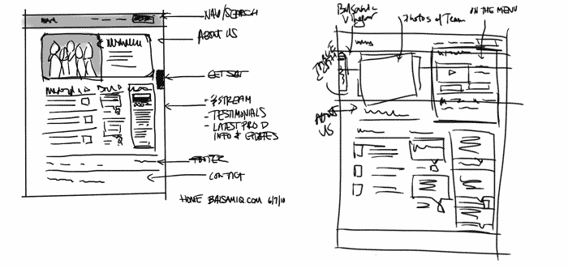

<http://blogs.balsamiq.com/ux/category/process/>

<http://delivery.acm.org/10.1145/230000/223514/p76-rudd.pdf?ip=130.223.144.214&id=223514&acc=ACTIVE%20SERVICE&key=C2716FEBFA981EF14F270D4CD1C44C51C88A9368D2EB7D73&CFID=396616080&CFTOKEN=61227188&__acm__=1389097411_676b01be17e49f42ada11d9c8d4d60f2>

1. Heaton, N. What’s wrong with the user interface: How rapid prototyping can help In IEE Colloquium on Software Prototyping and Evolutionary Digest London, IEE (1992), Digest No. 202, Part 7, pp. 1-5,